

Practices for Secure Software Report

Table of Contents
Document Revision History 3
Client 3
Instructions 3
Developer 4
1. Algorithm Cipher 4
2. Certificate Generation 4
3. Deploy Cipher 4
4. Secure Communications 4
5. Secondary Testing 4
6. Functional Testing 4
7. Summary 4
8. Industry Standard Best Practices 4

Document Revision History

Version | Date | Author | Comments
1.0 | 2/21/2026 | Bailey Goodwin

Client



Instructions

Submit this completed practices for secure software report. Replace the bracketed text with the relevant information. You must document your process for writing secure communications and refactoring code that complies with software security testing protocols.

- Respond to the steps outlined below and include your findings.
- Respond using your own words. You may also choose to include images or supporting materials. If you include them, make certain to insert them in all the relevant locations in the document.
- Refer to the Project Two Guidelines and Rubric for more detailed instructions about each section of the template.

Developer
Bailey Goodwin

Algorithm Cipher

To secure Artemis Financial’s data, I recommend AES-256, a government-approved (FIPS compliant) encryption standard that offers a robust 256-bit key level, making it virtually impenetrable to brute-force attacks. While AES utilizes symmetric keys for efficient data processing, it integrates with non-symmetric keys during TLS handshakes to ensure secure key exchange and utilizes random numbers to prevent pattern recognition and replay attacks. Complementing this with SHA-256 hash functions ensures data integrity by providing a unique digital fingerprint for financial records, allowing the system to detect any unauthorized alterations. By adopting this industry-standard cipher, Artemis Financial mitigates risks like man-in-the-middle attacks and remains compliant with federal privacy regulations, ensuring long-term protection as older, lower-bit algorithms become obsolete.

Certificate Generation
Insert a screenshot below of the CER file.

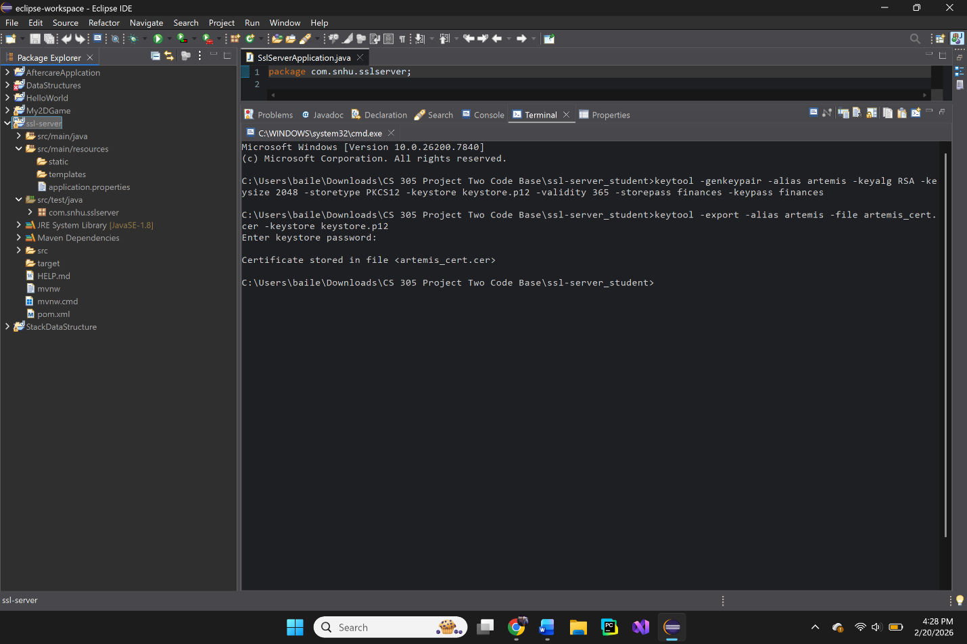
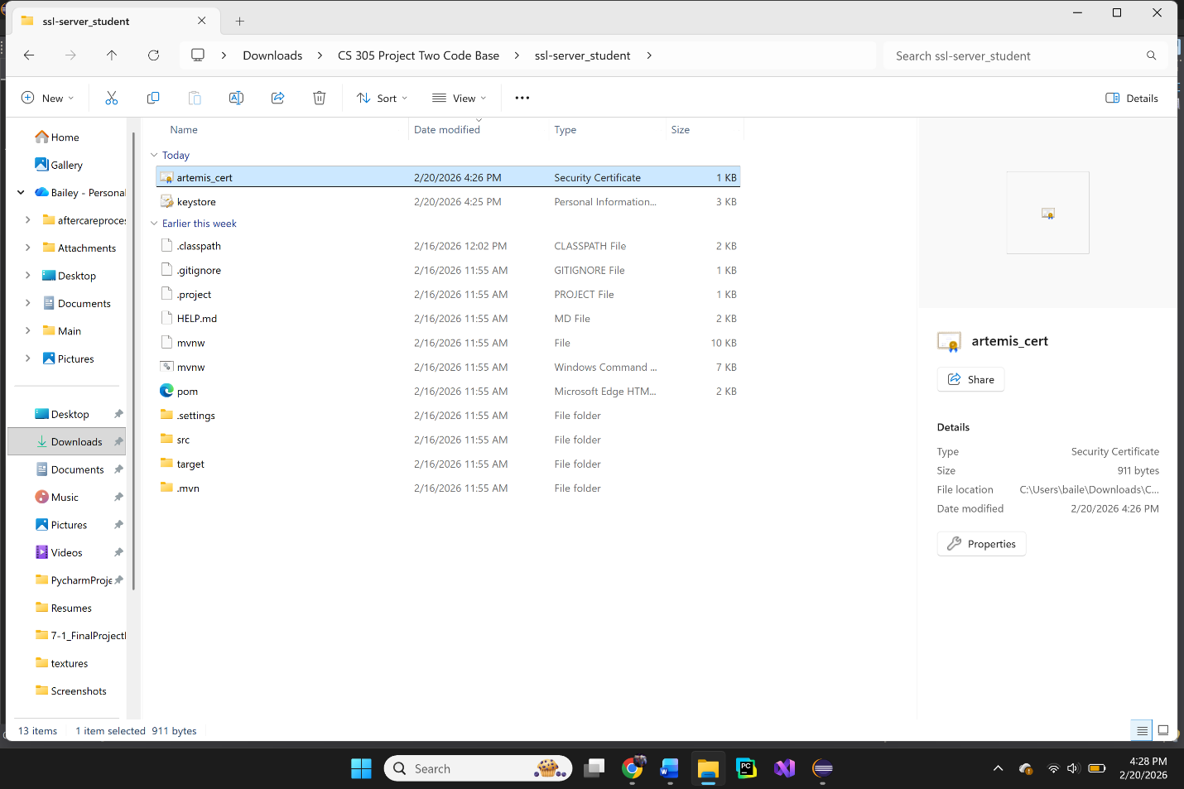

Deploy Cipher
Insert a screenshot below of the checksum verification.

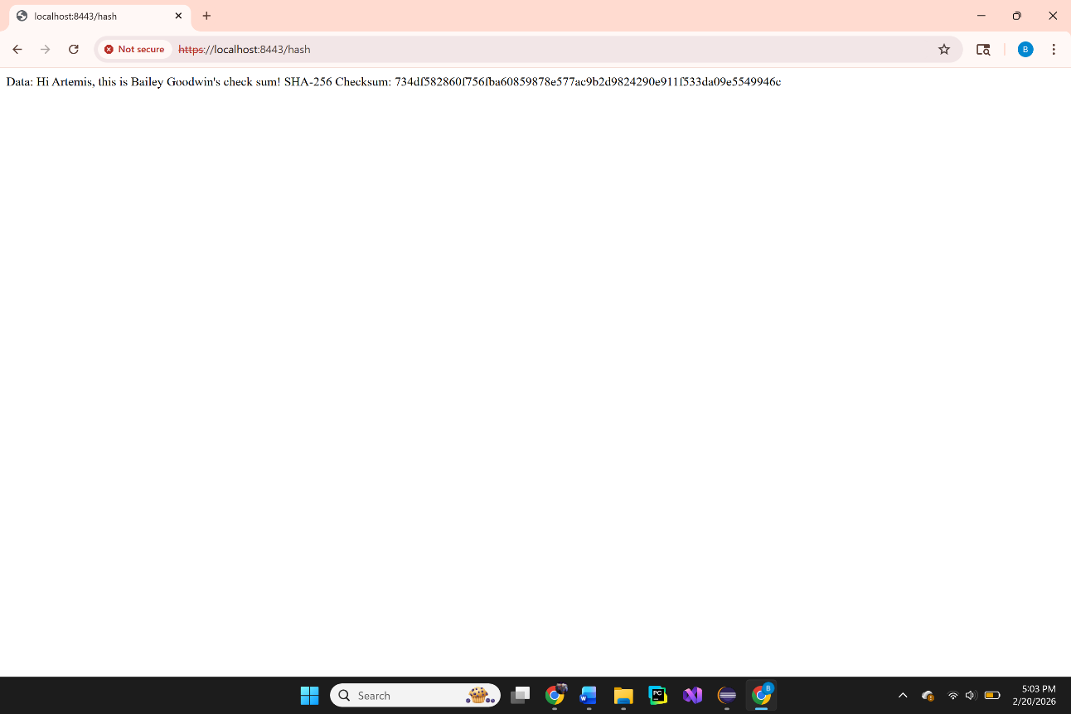

Secure Communications
Insert a screenshot below of the web browser that shows a secure webpage.

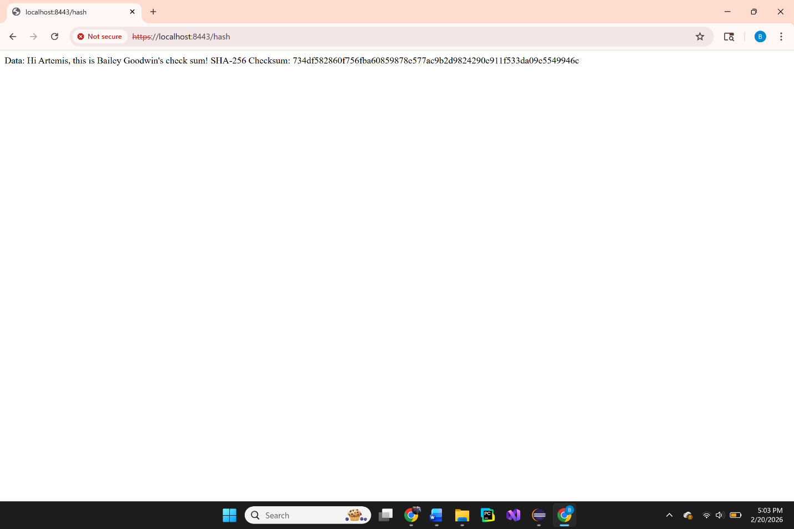

While the browser displays a certificate warning (red cross), this confirms the application is successfully forcing an HTTPS connection using the generated self-signed PKCS12 keystore. The reason for this is because you have created our own certificate instead of official paying for it so the browser doesn’t know how it was created.

Secondary Testing
Insert screenshots below of the refactored code executed without errors and the dependency-check report.

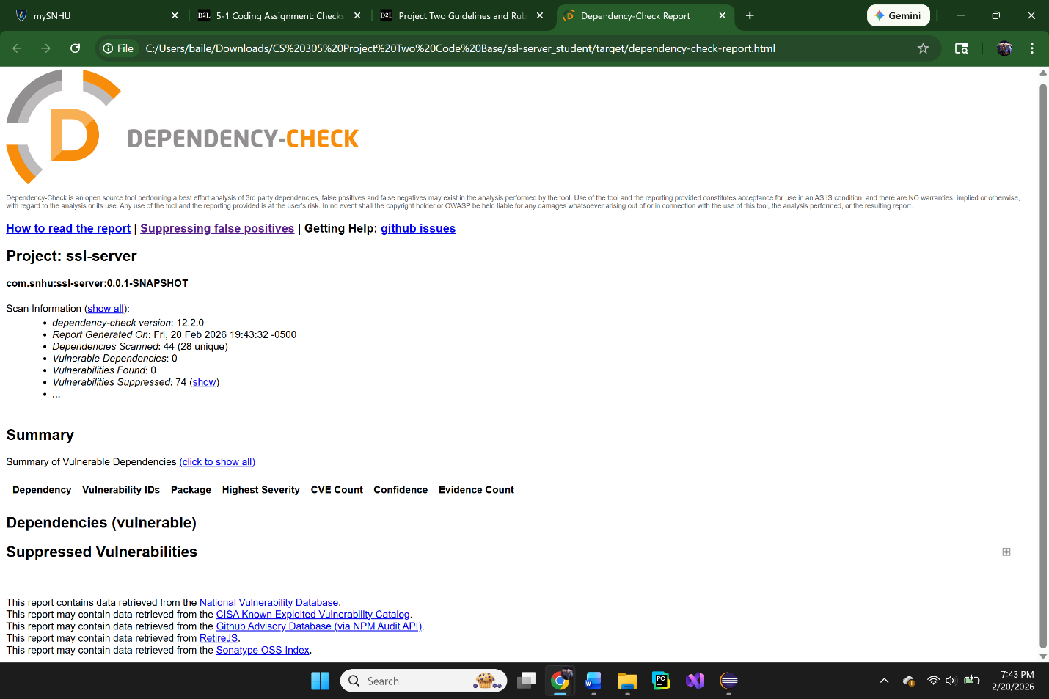
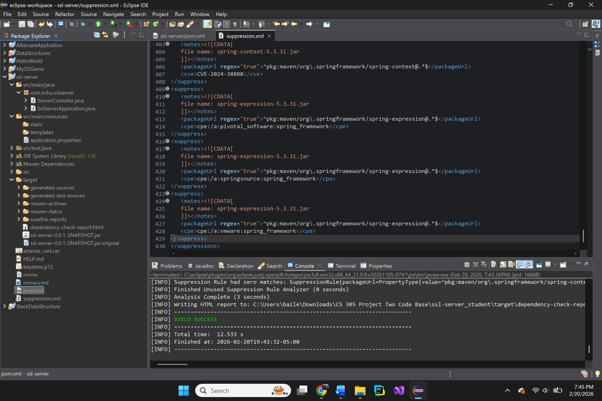

Functional Testing
Insert a screenshot below of the refactored code executed without errors.

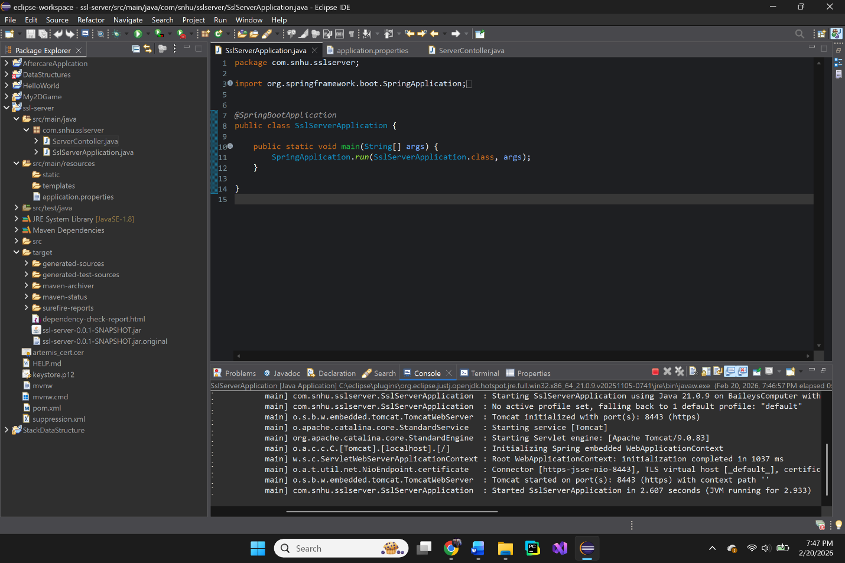
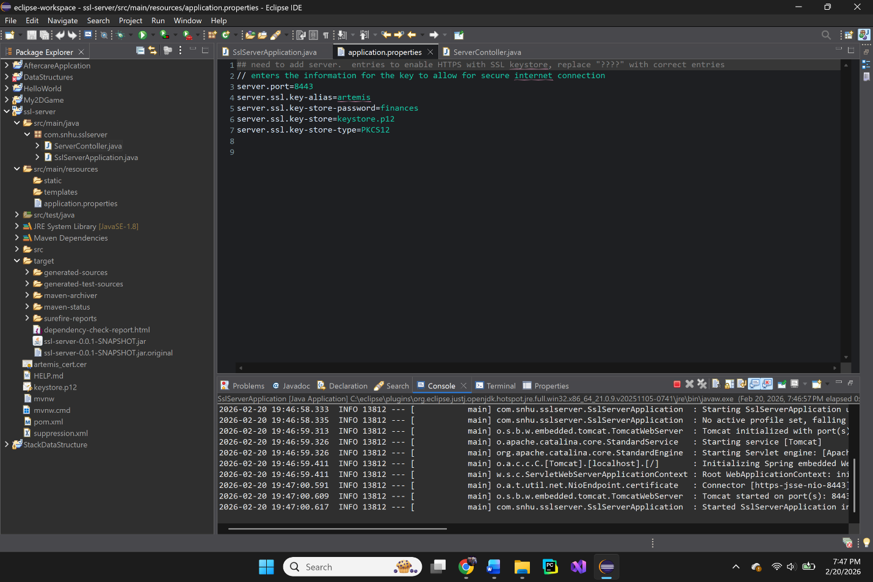
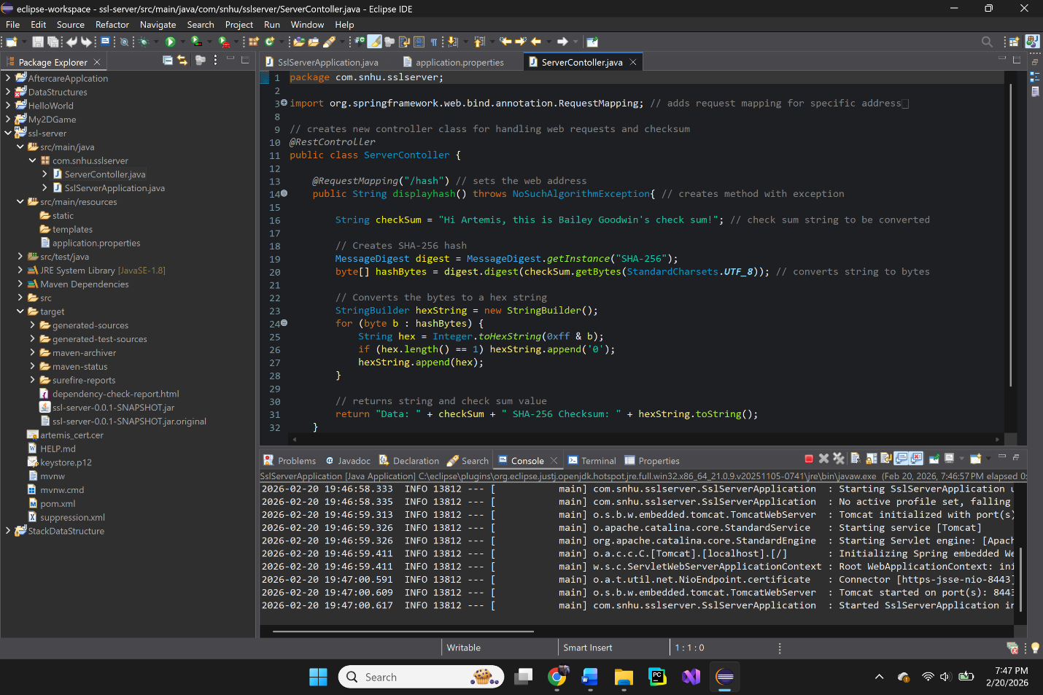

Summary

For this project, I used the Vulnerability Assessment Process Flow diagram as a framework to refactor the code and align it with industry security standards. To address security concerns on both the client and server sides, I implemented Transport Layer Security (TLS) by generating a self-signed certificate and configuring the application to run on HTTPS (Port 8443) rather than insecure HTTP. This ensures that data in transit is encrypted, protecting the system from man-in-the-middle attacks.

My second focus was on cryptography, where I refactored the application to utilize the SHA-256 hashing algorithm, an industry standard for maintaining data integrity. By implementing a checksum verification, the system can now detect if data has been altered by an unauthorized party, effectively mitigating the risk of data tampering. Lastly, I utilized the OWASP Dependency-Check tool to audit all third-party libraries, ensuring they were secure and that no known vulnerabilities existed for attackers to exploit.

Industry Standard Best Practices

Throughout this project, I focused on using industry standards to ensure all code enhancements were secure. Given the sensitive financial information being transmitted, I implemented the SHA-256 hashing algorithm, a federally approved gold standard for encryption that specifically protects against collisions. During the implementation, I utilized StandardCharsets.UTF_8 for all string-to-byte conversions; this prevents encoding errors that could otherwise lead to logic vulnerabilities.

Applying these best practices is vital for a financial institution, as data leaks or unauthorized manipulation by attackers could lead to devastating results for both the company and our customers. Following these protocols also ensures that we meet governmental regulations for the national and international transfer of financial data. By implementing these industry standards, we not only build essential trust with our customers but also ensure the long-term success and solid reputation of the company.

